9.99: a) Following the hint, the moment of inertia of a uniform sphere in terms of the mass density is 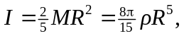 and so the difference in the moments of inertia of two spheres with the same density  but different radii 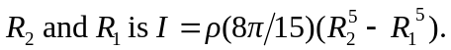

b) A rather tedious calculation, summing the product of the densities times the difference in the cubes of the radii that bound the regions and multiplying by 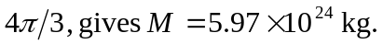 c) A similar calculation, summing the product of the densities times the difference in the fifth powers of the radii that bound the regions and multiplying by

